Lesson #7: Over-Privileged Function
DVSA Vulnerability Report | ICS-344
Part 1) Goal and Vulnerability Summary
This lesson demonstrates the Over-Privileged Function vulnerability in the DVSA serverless application. The affected component is the DVSA-SEND-RECEIPT-EMAIL Lambda function and its IAM execution role. The function is intended only to send receipt emails via SES, but its execution role grants wildcard access to Amazon S3, Amazon DynamoDB, and full SES administration. The security impact is a dramatically increased blast radius: if the function were ever compromised, an attacker would inherit permissions far beyond what is needed for sending emails. The core weakness is failure to enforce the principle of least privilege in IAM role design.
Part 2) Why This Works / Root Cause
In AWS serverless systems, any code running inside a Lambda function automatically inherits the temporary STS credentials of its execution role. The weakness is not in the business logic of the function itself, but in the excessive IAM permissions attached to its role. The original role included AmazonSESFullAccess (granting all SES admin actions), plus custom inline policies granting wildcard S3 access (arn:aws:s3:::*/*) and wildcard DynamoDB access (arn:aws:dynamodb:REGION:ACCOUNT:table/*). None of these broad permissions are required for the single task of sending a receipt email. The root cause is over-privileged role design and a failure to enforce least privilege at deployment time.
Part 3) Environment and Setup

AWS Services Involved
- Lambda Function: DVSA-SEND-RECEIPT-EMAIL
- IAM Role: serverlessrepo-OWASP-DVSA-SendReceiptFunctionRole-WzQCY5vwpBWQ
- CloudWatch Log Group: /aws/lambda/DVSA-SEND-RECEIPT-EMAIL
- CloudTrail Trail: dvsa-policygen-trail (us-east-1, multi-region)
- IAM Policy Simulator (AWS Console > IAM > Tools)

Tools Used
- AWS Management Console (IAM, Lambda, CloudWatch, CloudTrail)
- IAM Policy Simulator — to prove permissions are allowed beyond function scope
- IAM Access Analyzer Generate Policy — to show what is actually used
Part 4) Reproduction Steps

Step 1 — Locate the Lambda Function and Its Role
- Open AWS Console and navigate to Lambda > Functions.
- Search for DVSA-SEND-RECEIPT-EMAIL and open the function page.
- Go to Configuration tab > Permissions > click the execution role name to open it in IAM.

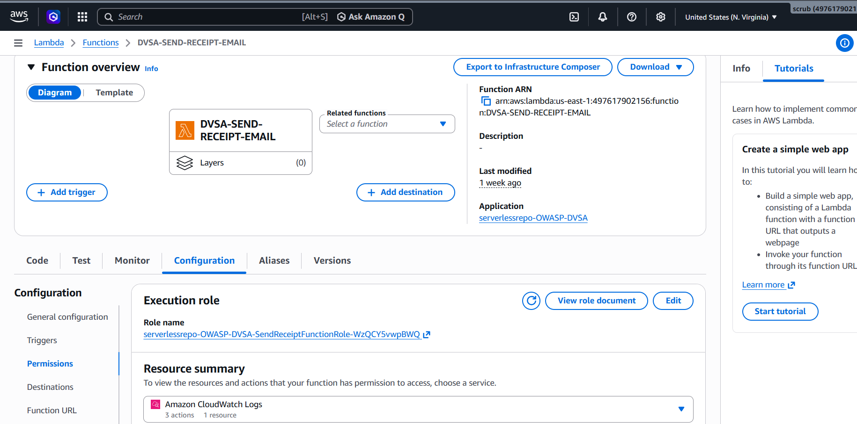

Step 2 — Review the Attached Policies
On the IAM role Permissions tab, the following 5 policies were attached:
- AWSLambdaBasicExecutionRole (AWS managed)
- AmazonSESFullAccess (AWS managed) — grants all SES administrative actions
- SendReceiptFunctionRolePolicy1 — S3 access with wildcard resource arn:aws:s3:::*/*
- SendReceiptFunctionRolePolicy2 — DynamoDB access with wildcard table/*
- SendReceiptFunctionRolePolicy3 — STS GetCallerIdentity

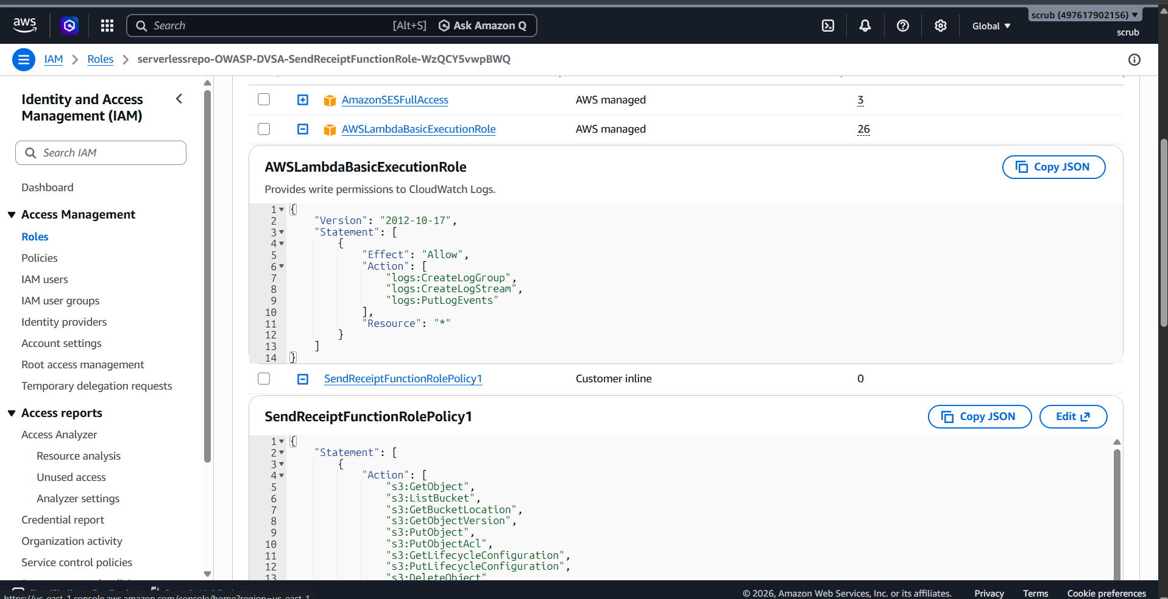

Step 3 — Prove Over-Privilege with IAM Policy Simulator
- Go to IAM > Tools > Policy Simulator. Change identity type to Roles and select the receipt function role.
- Select Amazon S3, add actions GetObject and PutObject. Set resource: arn:aws:s3:::some-other-bucket/key. Click Run Simulation.
- Result: both actions returned ALLOWED on an unrelated bucket.
- Repeat for Amazon DynamoDB with Scan, PutItem, DeleteItem on an arbitrary table ARN.
- Result: all DynamoDB actions returned ALLOWED on unrelated tables.

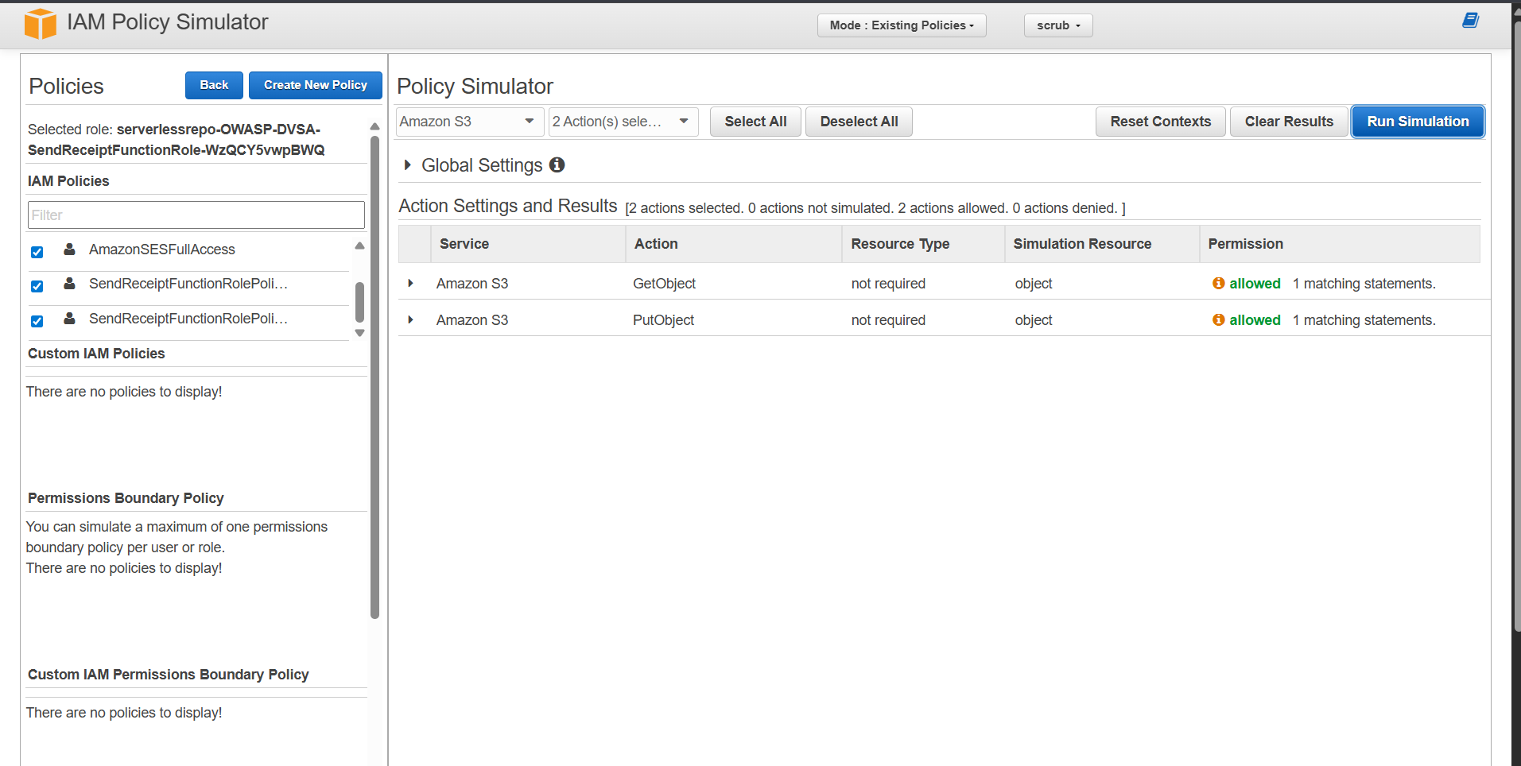

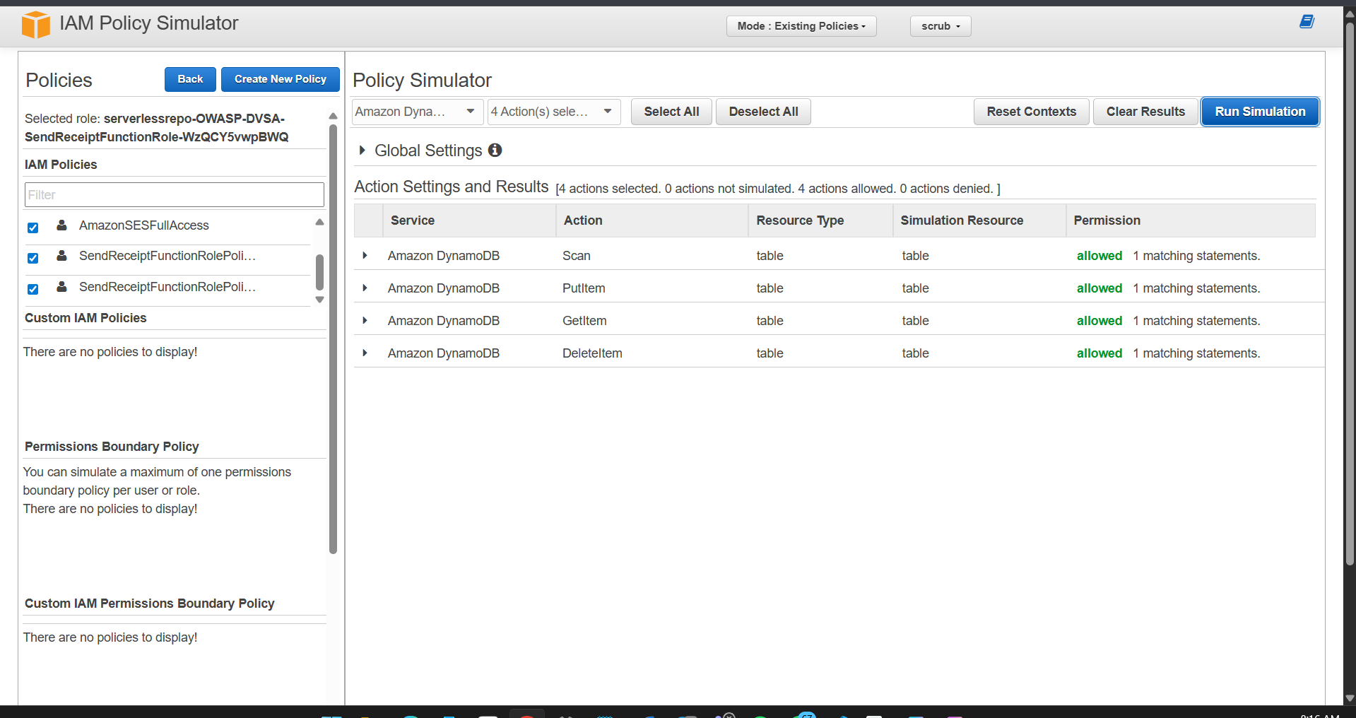

Step 4 — Generate Least-Privilege Policy via CloudTrail
- Created CloudTrail trail dvsa-policygen-trail (multi-region, management events on).
- Placed an order on the DVSA site to trigger the Lambda function.
- Confirmed invocation in CloudWatch Logs — START, END, and REPORT entries visible.
- Opened IAM role > Generate policy > Last 1 day > us-east-1 > dvsa-policygen-trail > Generate policy.
- Reviewed results on the Review Permissions page.

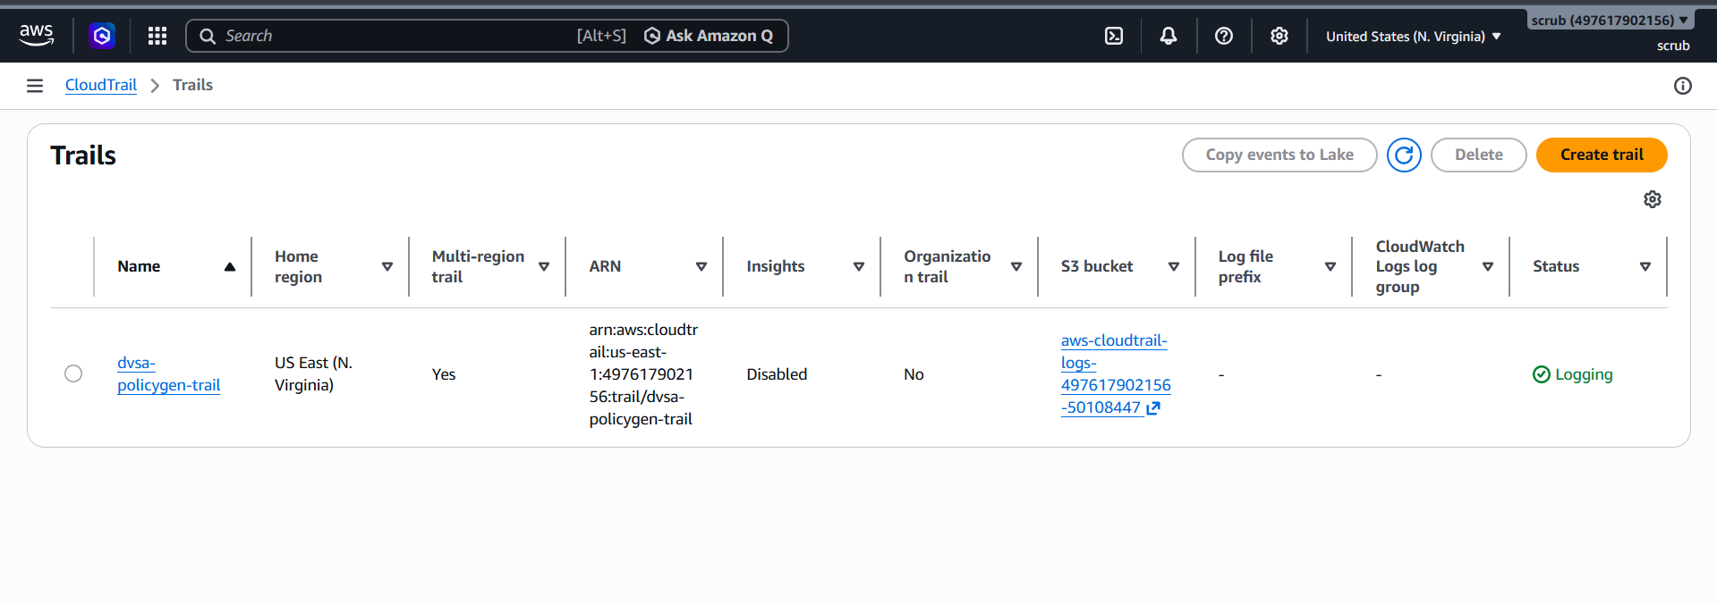

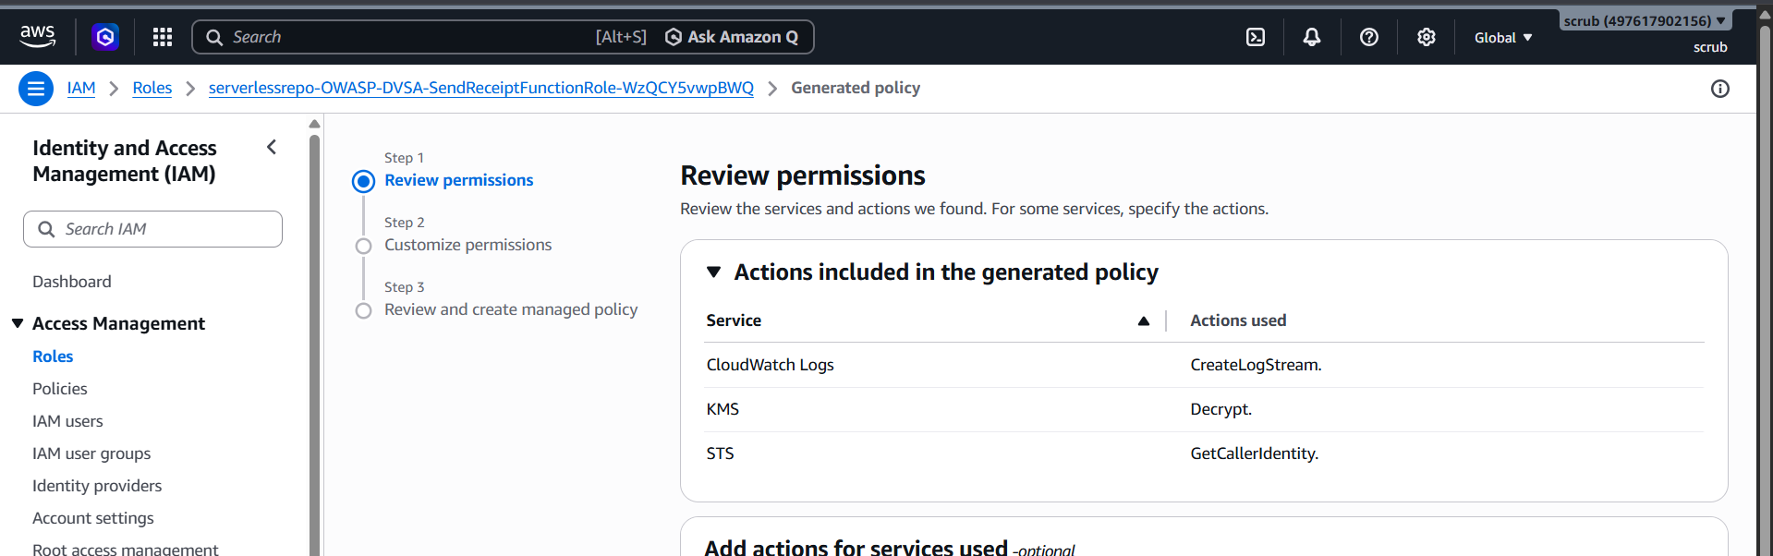IAM Generate Policy — Review Permissions page showing only 3 actions actually used: CreateLogStream, KMS:Decrypt, STS:GetCallerIdentity

Part 5) Evidence and Proof
- IAM Policy Simulator confirmed s3:GetObject and s3:PutObject were ALLOWED on arn:aws:s3:::some-other-bucket/key — a bucket entirely unrelated to receipts.
- IAM Policy Simulator confirmed dynamodb:Scan, dynamodb:PutItem, and dynamodb:DeleteItem were ALLOWED on arbitrary DynamoDB tables.
- CloudTrail-generated policy showed only 3 actions were actually used during a real invocation: CloudWatch Logs:CreateLogStream, KMS:Decrypt, STS:GetCallerIdentity. No S3 or DynamoDB access was observed.
- CloudWatch Logs confirmed the function executed successfully (START/END/REPORT), proving it does not need S3 or DynamoDB access to complete its task.
The contrast between what the role permits (5 broad policies with wildcards) and what the function actually uses (3 narrow actions) is definitive proof of over-privilege.

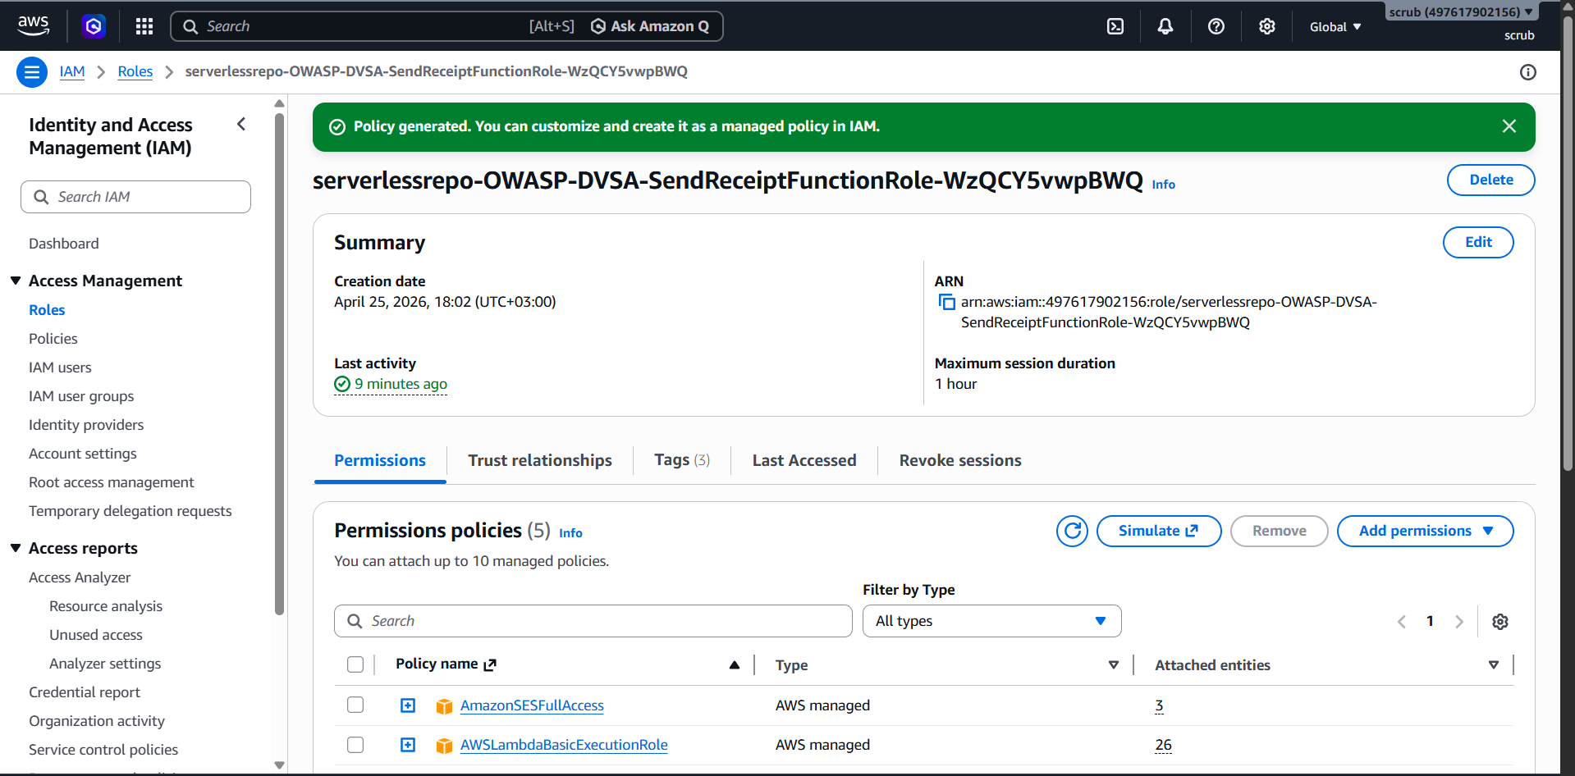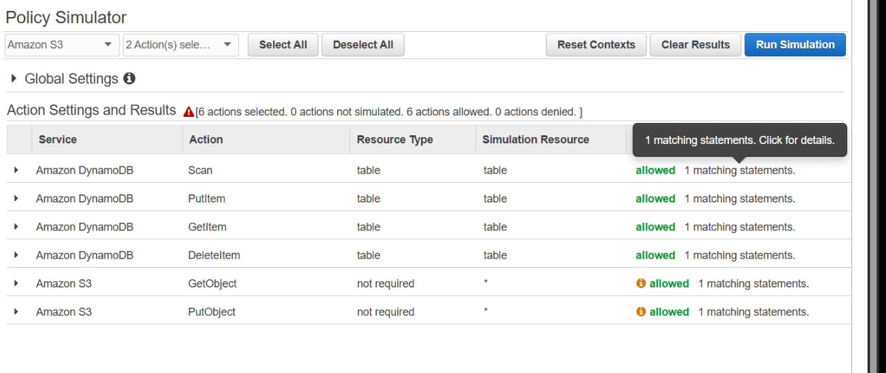

Part 6) Fix Strategy / Probable Mitigation
The fix belongs in the IAM execution role attached to DVSA-SEND-RECEIPT-EMAIL. Three changes are required:
- Remove AmazonSESFullAccess entirely — the function does not need SES administrative permissions.
- Replace the wildcard S3 policy with a scoped policy allowing only s3:GetObject on the specific DVSA receipts bucket.
- Replace the wildcard DynamoDB policy with a scoped policy allowing only dynamodb:GetItem on DVSA-prefixed tables.
This addresses the root cause by eliminating the blast radius: even if the function is compromised, an attacker can only perform the exact actions the function legitimately needs, scoped to the exact resources it uses.
Part 7) Code / Config Changes

Change 1 — Removed AmazonSESFullAccess
Detached the AWS managed policy AmazonSESFullAccess from the role. This policy granted all SES administrative actions and was completely unnecessary since the function only needs ses:SendEmail.

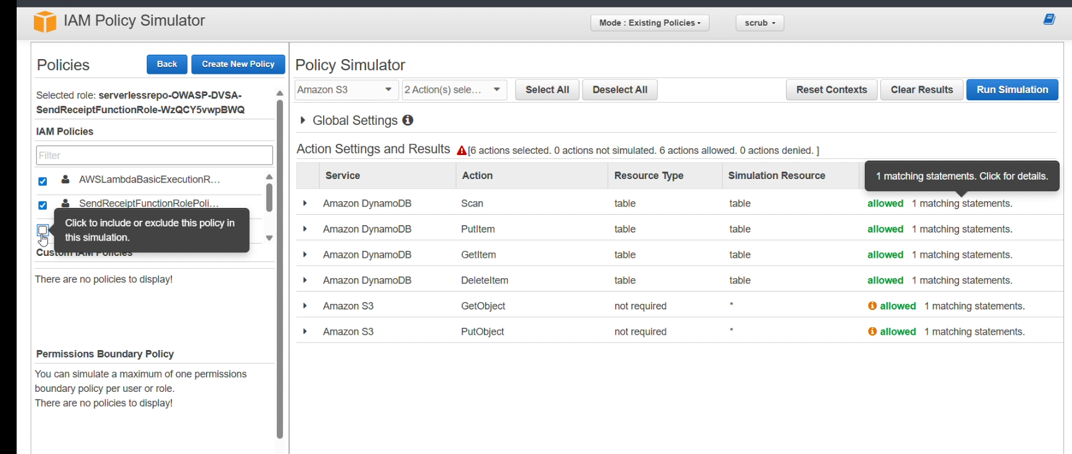
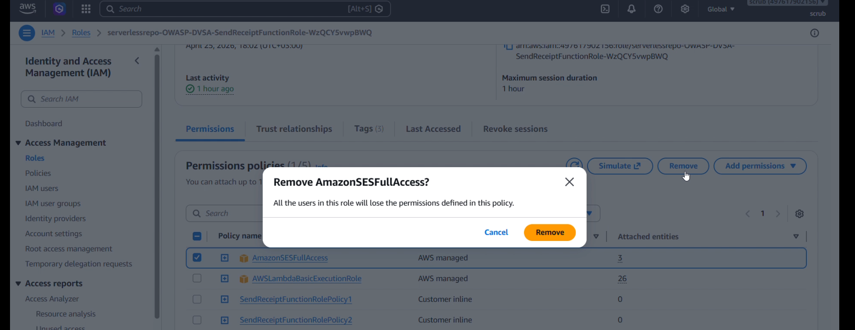IAM Role Permissions tab after removing AmazonSESFullAccess — now showing 4 policies with Policy removed banner

Change 2 — Scoped SendReceiptFunctionRolePolicy1 (S3)
Before (vulnerable):
{ "Effect": "Allow", "Action": ["s3:GetObject", "s3:PutObject", "s3:ListBucket", ...], "Resource": "arn:aws:s3:::*/*" }
After (fixed):
{ "Effect": "Allow", "Action": ["s3:GetObject"], "Resource": "arn:aws:s3:::dvsa-*receipts*/*" }

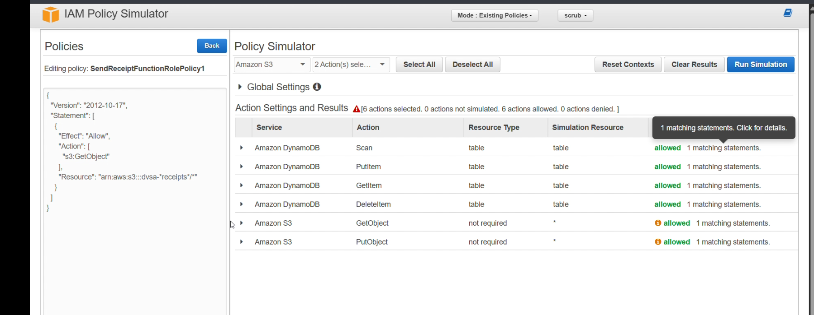
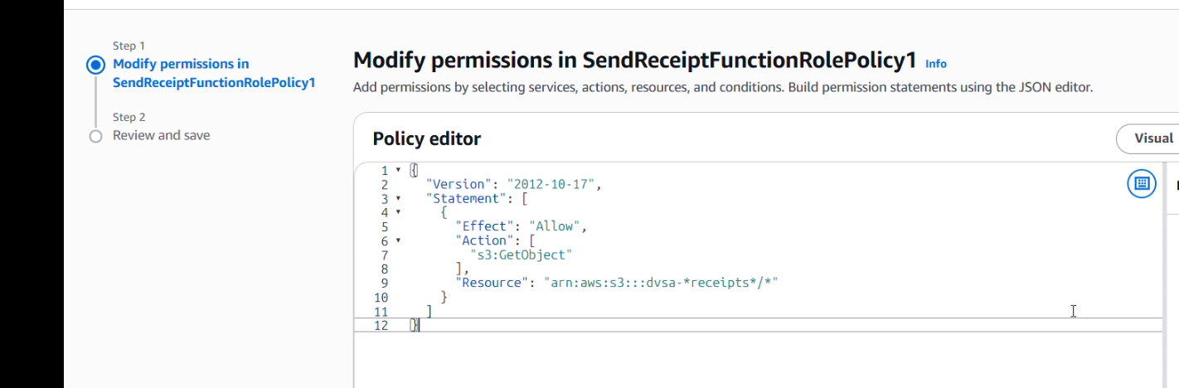
Policy editor showing updated SendReceiptFunctionRolePolicy1 with scoped S3 resource

Change 3 — Scoped SendReceiptFunctionRolePolicy2 (DynamoDB)
Before (vulnerable):
{ "Effect": "Allow", "Action": ["dynamodb:Scan", "dynamodb:PutItem", "dynamodb:DeleteItem", ...], "Resource": "arn:aws:dynamodb:us-east-1:497617902156:table/*" }
After (fixed):
{ "Effect": "Allow", "Action": ["dynamodb:GetItem"], "Resource": "arn:aws:dynamodb:us-east-1:497617902156:table/DVSA-*" }

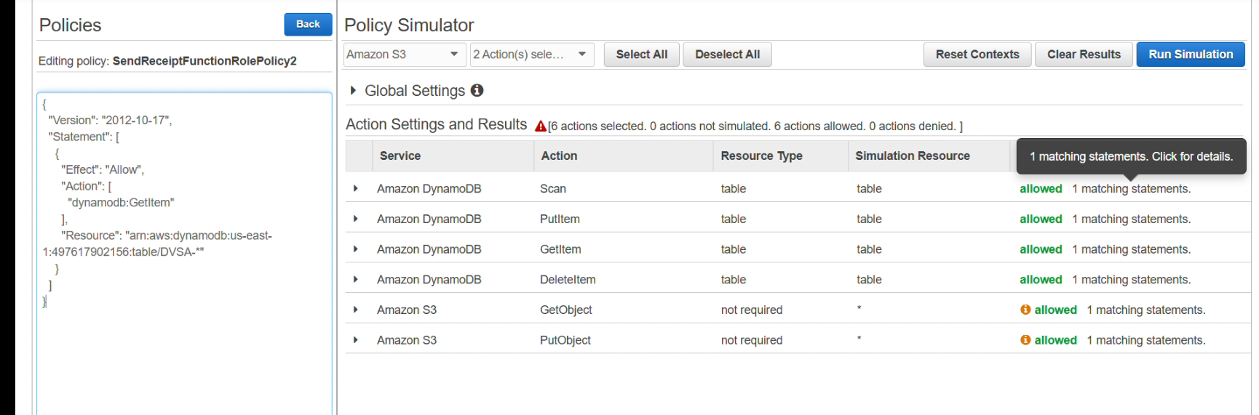

Policy editor showing updated SendReceiptFunctionRolePolicy2 with scoped DynamoDB resource

Change 4 — SendReceiptFunctionRolePolicy3 (STS) — No Change
STS:GetCallerIdentity is a harmless read-only identity check. AWS does not support resource-level restrictions for this action, so Resource: "*" is the only valid value. This policy was left unchanged.
Part 8) Verification After Fix
After applying all three changes, the IAM Policy Simulator was re-run with the same test cases used in the exploit demonstration:
- Amazon S3 — GetObject, PutObject, DeleteObject on arn:aws:s3:::some-other-bucket/key: all returned DENIED (implicitly denied, no matching statement).
- Amazon DynamoDB — Scan, PutItem, DeleteItem on an unrelated table: all returned DENIED.
The role now contains only 4 policies (down from 5), and all custom inline policies are scoped to specific DVSA resources. The function continued to execute its receipt email workflow correctly after the fix — CloudWatch Logs showed successful invocations.

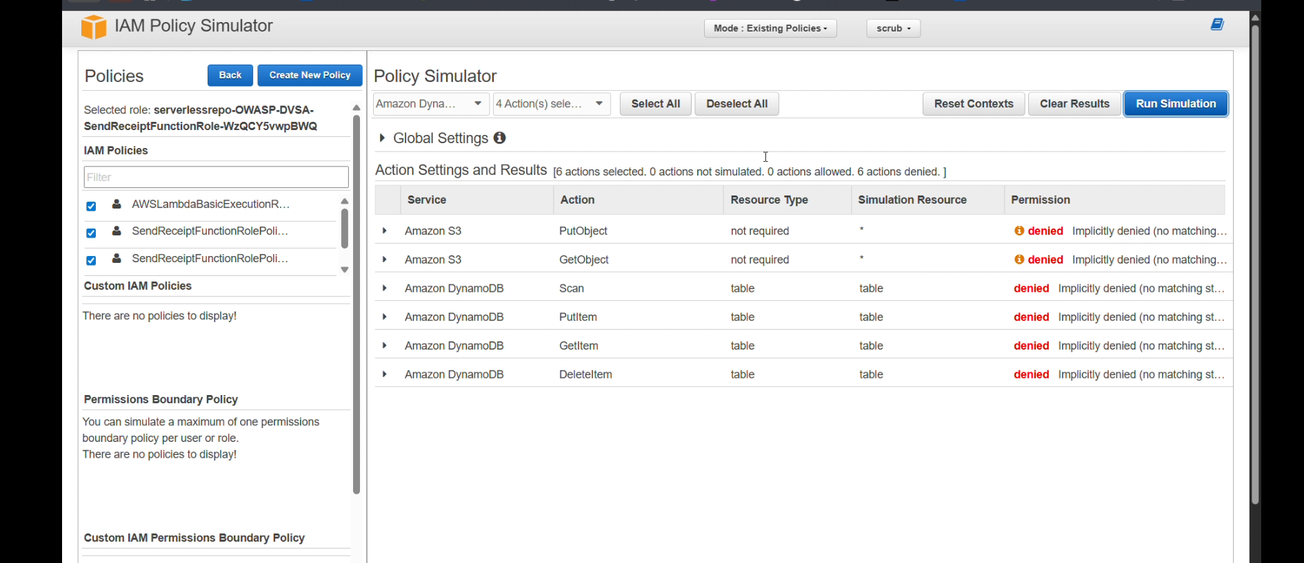

Part 9) Structured Operation and Security Analysis

Intended Logic and Security Rule(s)
The DVSA-SEND-RECEIPT-EMAIL Lambda function is triggered by S3 events when a receipt object is created. Its intended workflow is: receive the S3 event, retrieve the relevant order record, and send a receipt email to the customer via SES. The function should only need access to the specific receipts S3 bucket, the relevant DVSA DynamoDB table, and ses:SendEmail. The security rule is: a Lambda execution role must grant only the minimum permissions required for its specific task, scoped to the exact AWS resources involved — nothing more.

Evidence Sources and Behavior Trace
- Normal behavior: CloudTrail-generated policy confirmed only 3 actions (CreateLogStream, KMS:Decrypt, STS:GetCallerIdentity) were used during a real invocation.
- Exploit behavior: IAM Policy Simulator confirmed s3:PutObject and dynamodb:Scan were ALLOWED on arbitrary unrelated resources.
- Post-fix behavior: IAM Policy Simulator confirmed all unrelated S3 and DynamoDB actions returned DENIED after policy scoping.

Deviation Analysis and Classification
The exploit violates the least-privilege rule because the role grants wildcard access to all S3 buckets, all DynamoDB tables, and full SES administration. None of these broad permissions are needed. An attacker who compromises the function — through a code bug, injection, or supply-chain attack — would immediately inherit these permissions. This is classified as an Accidental Misconfiguration: the developer likely attached convenience policies during development and never restricted them before deployment.

Table A — Structured Analysis Summary

Vulnerability | Intended Rule(s) | Artifacts Used | Normal Behavior Evidence | Exploit Behavior Evidence
Lesson #7: Over-Privileged Function | The Lambda execution role must only grant the minimum permissions required for its task. No wildcard S3, DynamoDB, or SES admin access should be attached to a receipt-email function. | IAM role Permissions tab (5 policies), IAM Policy Simulator results (Allowed), CloudTrail-generated policy (3 actions only), CloudWatch logs confirming invocation. | CloudTrail-generated policy showed only 3 actions used: CreateLogStream, KMS:Decrypt, STS:GetCallerIdentity. No S3 or DynamoDB access was observed during a normal receipt email run. | IAM Policy Simulator confirmed s3:GetObject, s3:PutObject, dynamodb:Scan, dynamodb:PutItem, dynamodb:DeleteItem all returned ALLOWED on arbitrary unrelated resources due to wildcard policies.

Table B — Structured Analysis Summary

Vulnerability | Why This Is a Deviation | Deviation Class | Fix Applied (Where) | Post-Fix Verification | Optional Latency
Lesson #7: Over-Privileged Function | The role grants wildcard S3/DynamoDB/SES permissions far beyond what the function uses. Any compromise of the function exposes the full blast radius of these permissions, violating least privilege. | Accidental Misconfiguration | IAM Role (SendReceiptFunctionRole): Removed AmazonSESFullAccess; scoped S3 to receipts bucket only (GetObject); scoped DynamoDB to DVSA-* tables with GetItem only. | IAM Policy Simulator re-run after fix: s3:PutObject, dynamodb:Scan, dynamodb:DeleteItem on unrelated resources all returned DENIED. Function continued to run successfully post-fix. | N/A

Part 10) Takeaway / Lessons Learned
In serverless architectures, the Lambda execution role is the identity of the function. Over-privileged roles transform a small bug or injection vulnerability into a full AWS account compromise — a receipt email function becomes a gateway to scan all customer orders, read or write arbitrary S3 objects, or misuse SES for spam campaigns. The key lesson is that least privilege is not optional in cloud security: every IAM role must be scoped to the exact actions and resources the function legitimately needs, and nothing more. Tools like IAM Access Analyzer and CloudTrail-based policy generation make it straightforward to identify and eliminate excess permissions before they become exploitable in production.

